Form

app

*import* React, { Component } *from* 'react';

*import* Usama *from* './usama'

*import* AddNinja *from* './AddNinja'

class App extends Component {

  state = {

    ninjas: [

      { name: 'Ryu', age: 30, belt: 'black', id: 1 },

      { name: 'Yoshi', age: 20, belt: 'green', id: 2 },

      { name: 'Crystal', age: 25, belt: 'pink', id: 3 }

    ]

  }

  addninja=(ninja)=>{

    ninja.id=Math.random();

*//  let ninjad=[...this.state.ninjas,ninja];*

     console.log(ninja)

     this.setState({

       ninjas:[...this.state.ninjas,ninja]

     })

  }

  dltninja=(id)=>{

console.log(id)

let ninjas=this.state.ninjas.filter(ninja=>{

*return* ninja.id!==id

});

this.setState({

  ninjas:ninjas

})

}

  render() {

*return* (

      <div className="App">

        <h1>My first React app</h1>

        <Usama dlt={this.dltninja} ninjas={this.state.ninjas}/>

      <AddNinja addninja={this.addninja} />

      </div>

    );

  }

}

*export* *default* App;

usamam

*import* React *from* 'react'

const usama = ({ninjas,dlt}) => {

       const ninjauhk=ninjas.map(l=>{

*return* l.age>20 ? (

              <div key={l.id}>

            <div>{l.name}</div>

            <div>{l.age}</div>

            <div>{l.belt}</div>

            <button onClick={()=>{dlt(l.id)}}>dlt</button>

            </div>

          ): null

      })

*return*(

          <div>

         {ninjauhk}

          </div>

      )

}

*export* *default* usama

addap

*import* React, { Component } *from* 'react'

*export* *default* class AddNinja extends Component {

state={

    name:null,

    age:null,

    belt:null

}

onhandlebutton=(e)=>{

    this.setState({

        [e.target.id]:e.target.value

    })

}

onsubmithandle=(e)=>{

*// console.log("done",this.state)*

    this.props.addninja(this.state)

    e.preventDefault()

}

    render() {

*return* (

            <div>

                <form onSubmit={this.onsubmithandle}>

<label htmlFor='name' > name</label>

<input type='text' id="name" onChange={this.onhandlebutton}  />

<label htmlFor='age'  > Age</label>

<input type='text' id="age" onChange={this.onhandlebutton}   />

<label htmlFor='belt'  > Belt</label>

<input type='text' id="belt"  onChange={this.onhandlebutton} />

<button type='submit' onClick={this.onsubmithandle}>Submit</button>

                </form>

            </div>

        )

    }

}

Routing

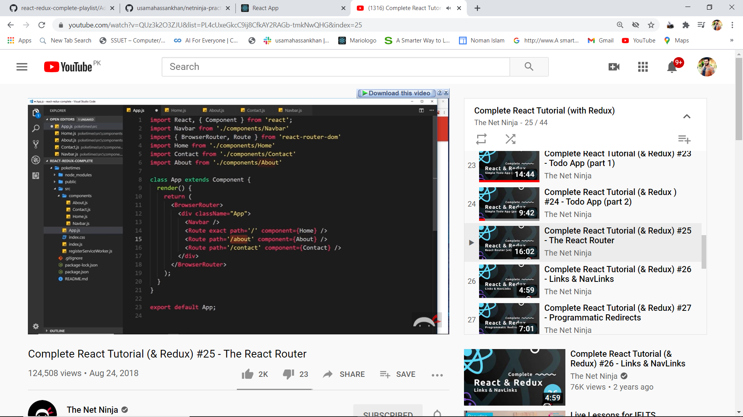

Link and navlink replace href

Navlink has active class whon hover

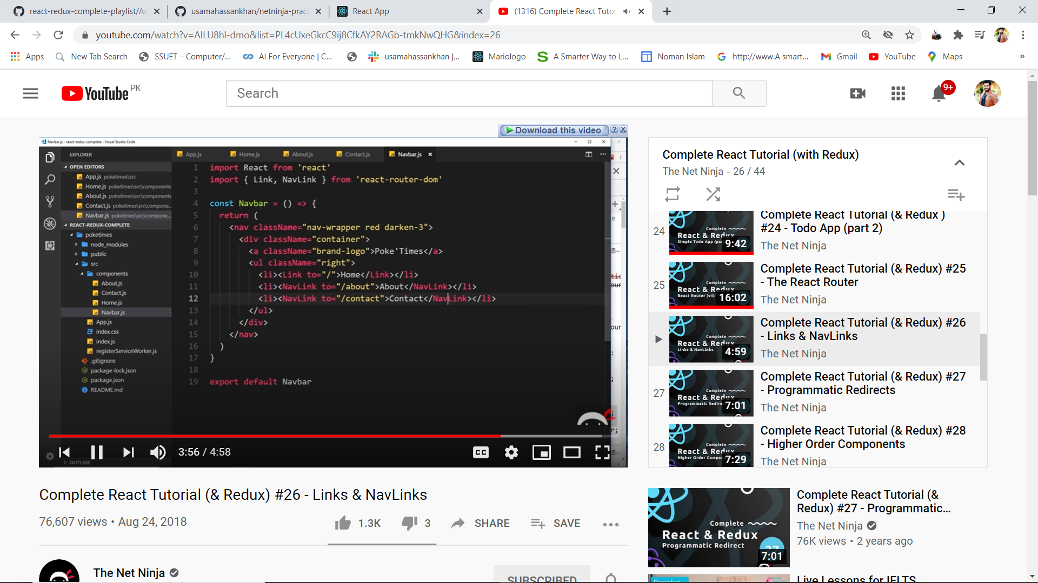

Programmatic redirect

] 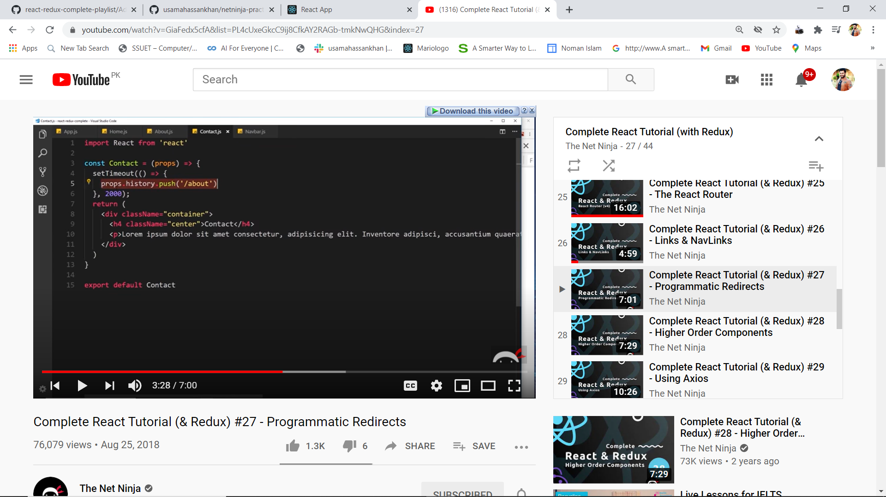

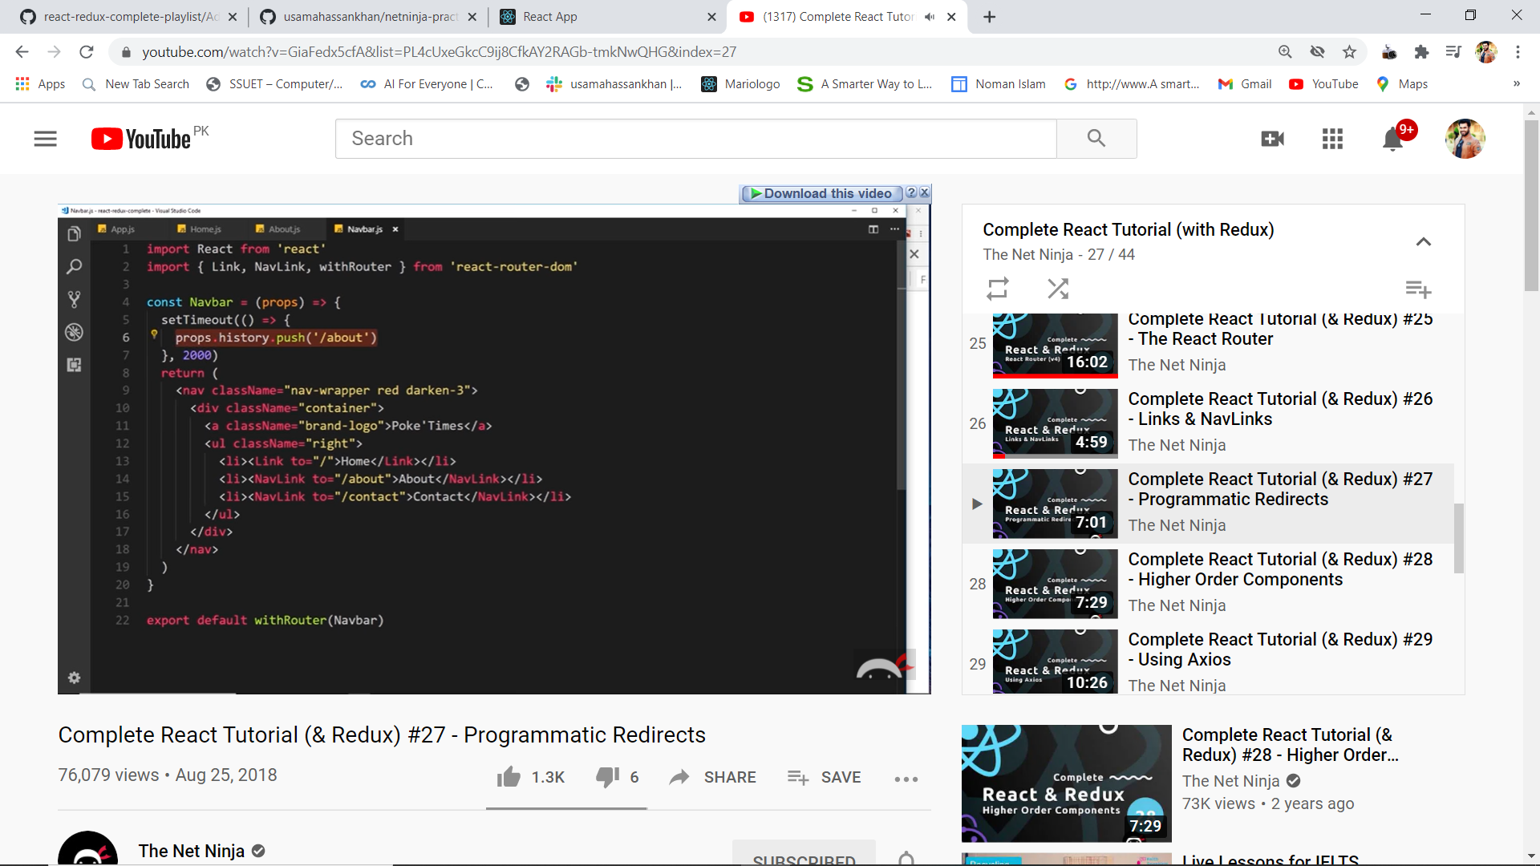

If compont is not a part of route so import withrouter and wrap with higher order component

Axios

Npm install axios

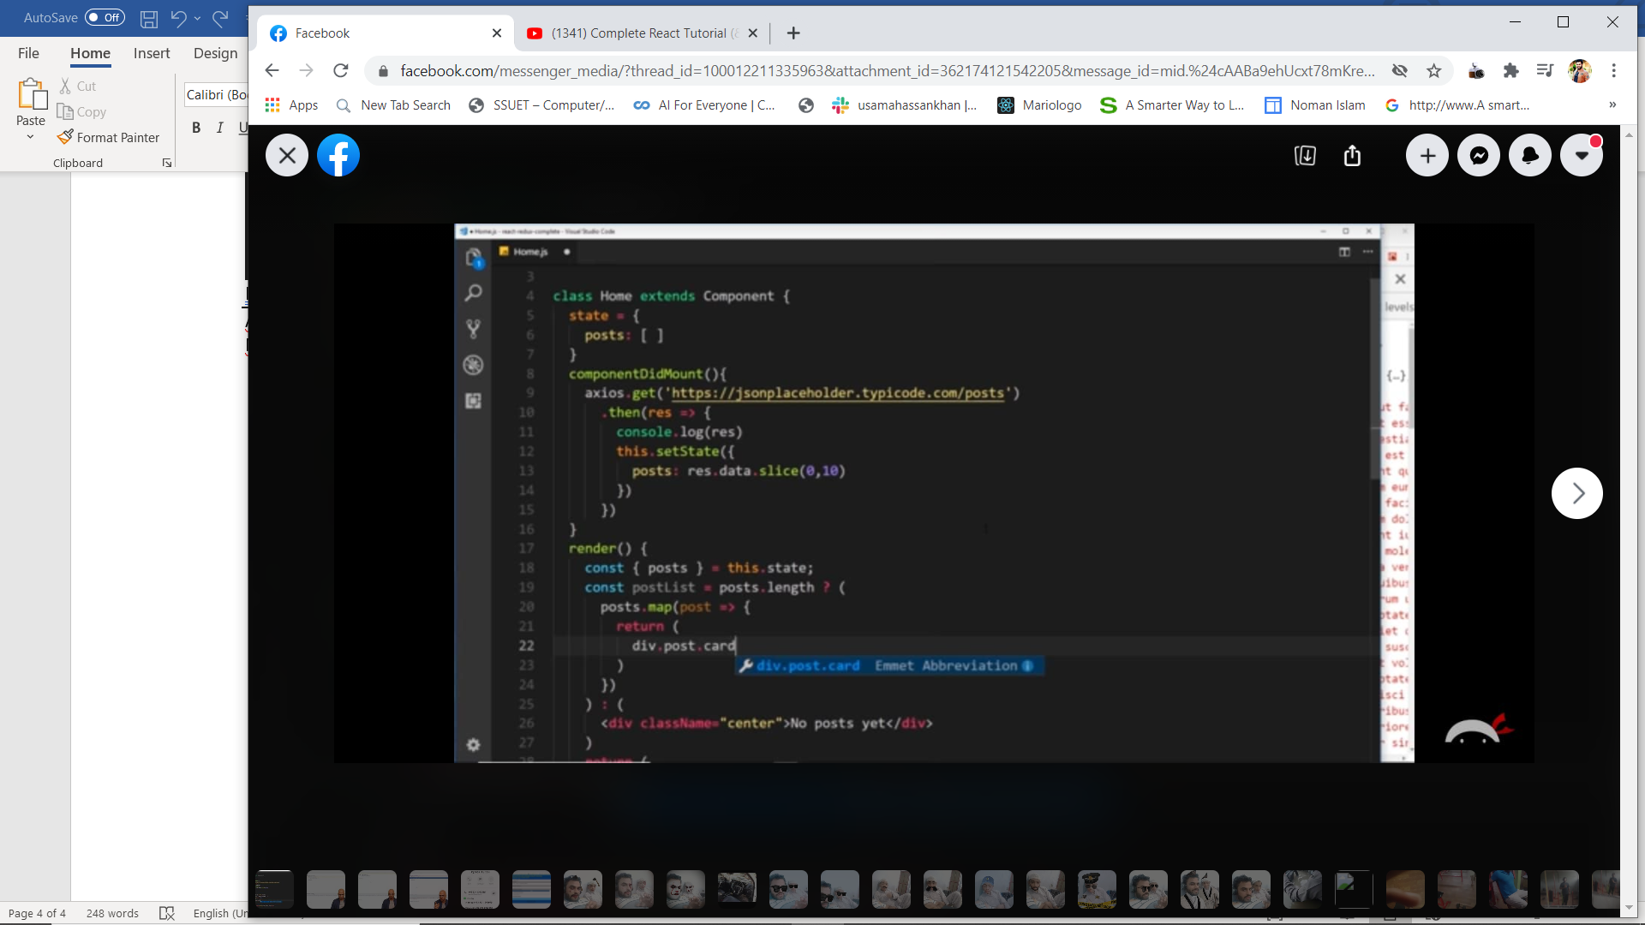

Router parameter

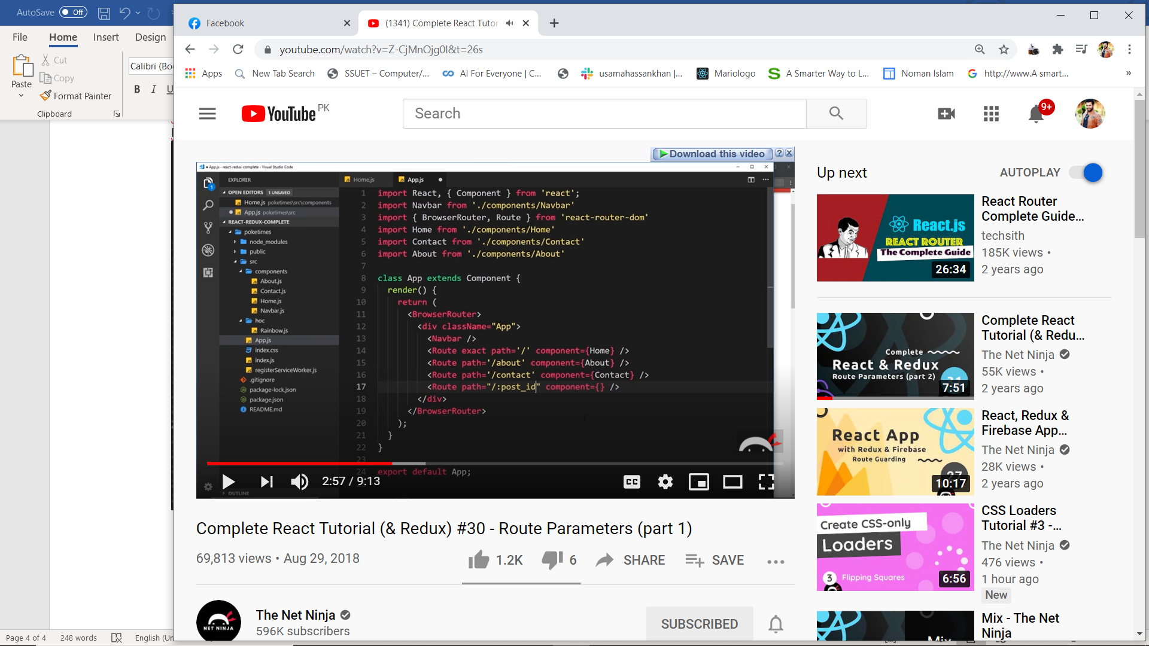

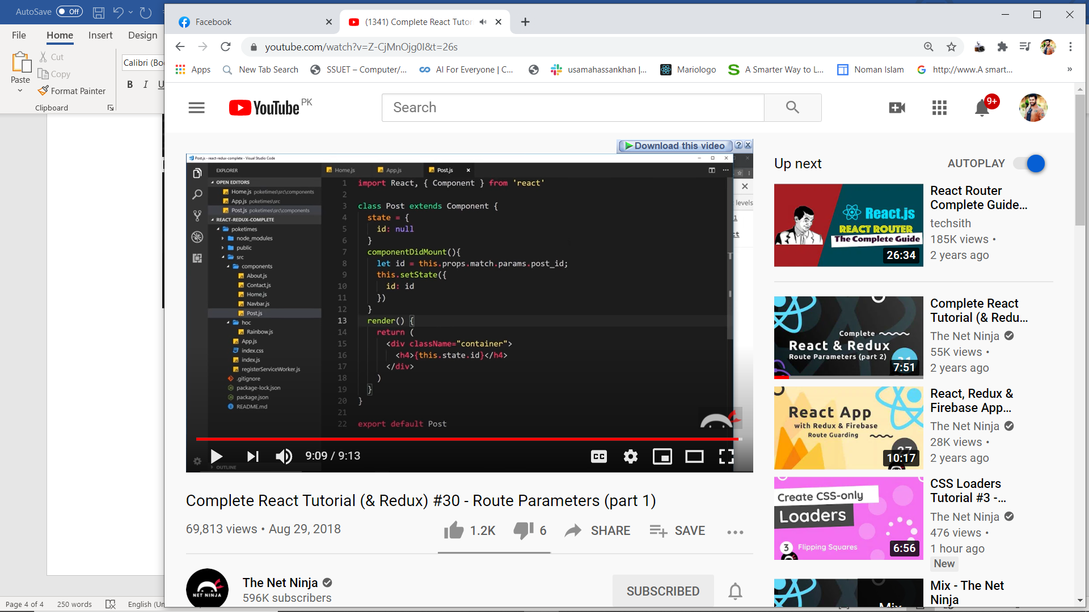

Get specif post from id

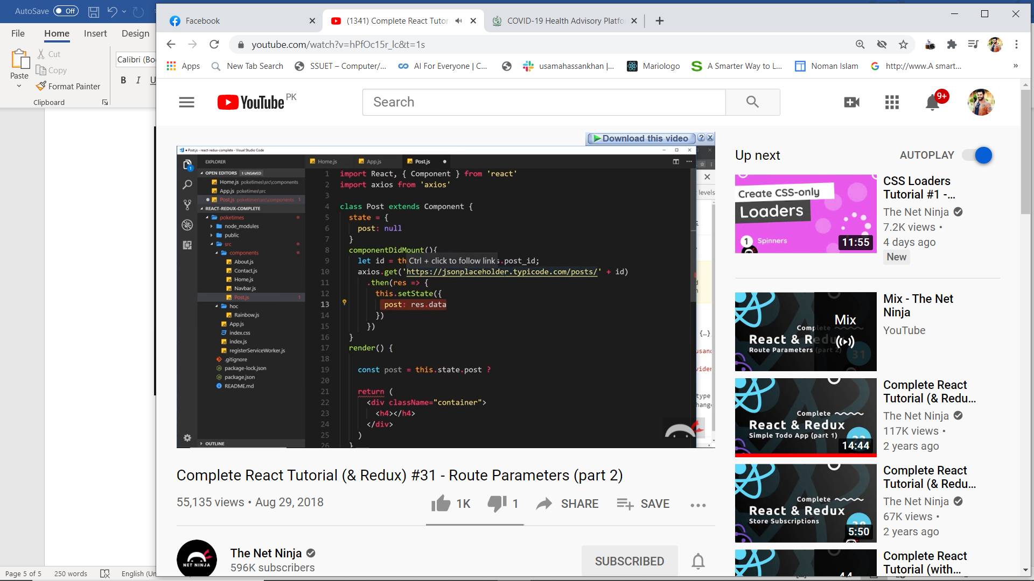

Import image

Import imag name fromm ’ ./pokebo.png’

Then

<img src={image name} />

Redux

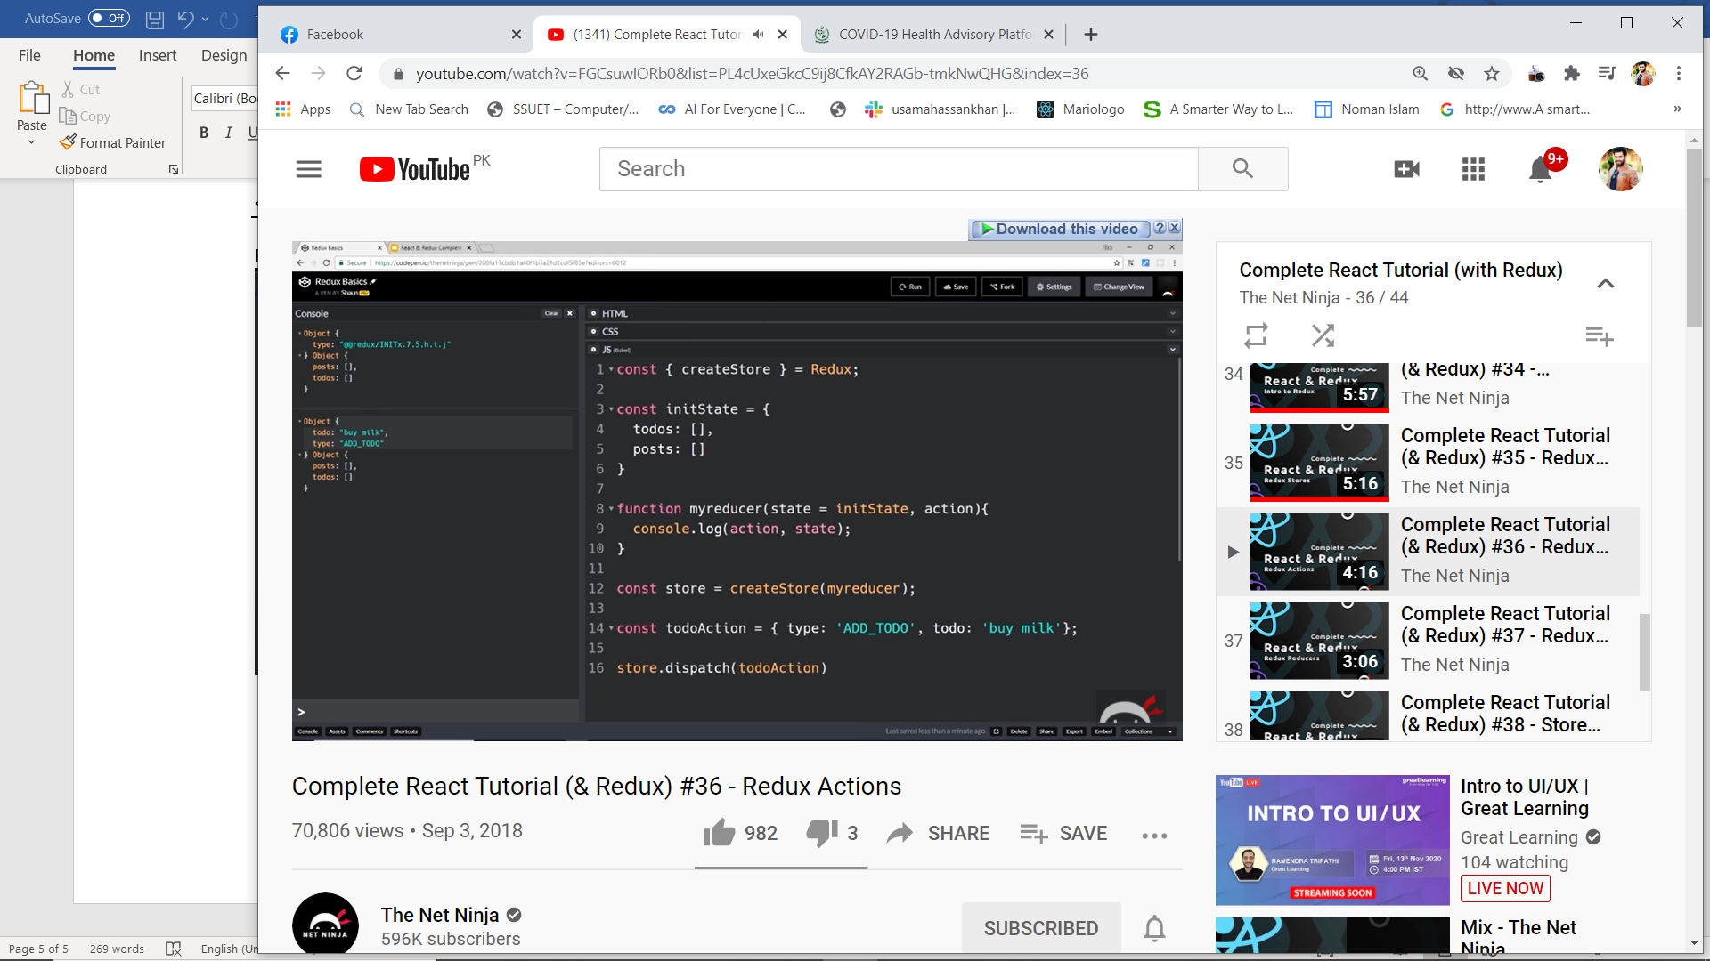

Action

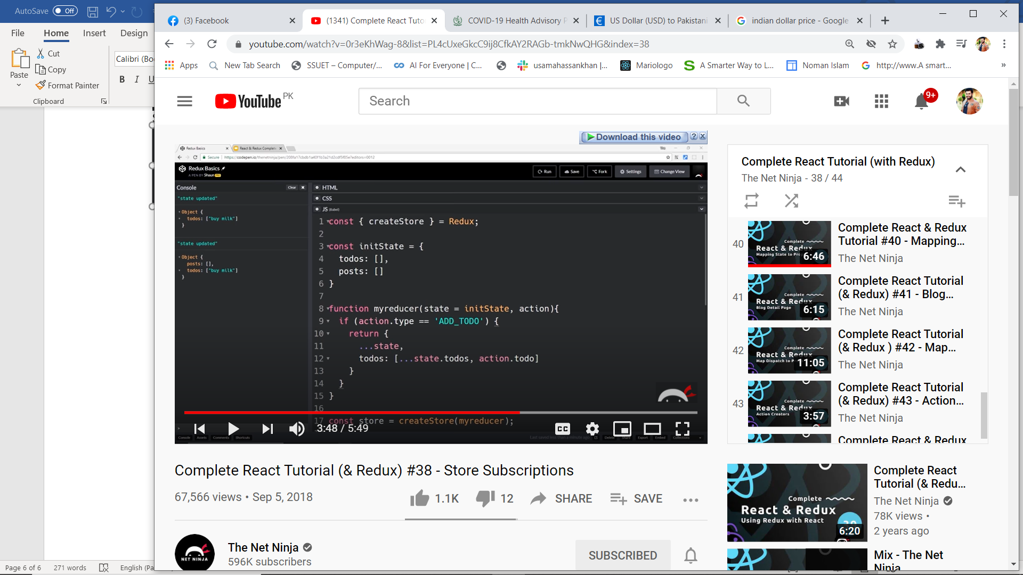

Subscribe

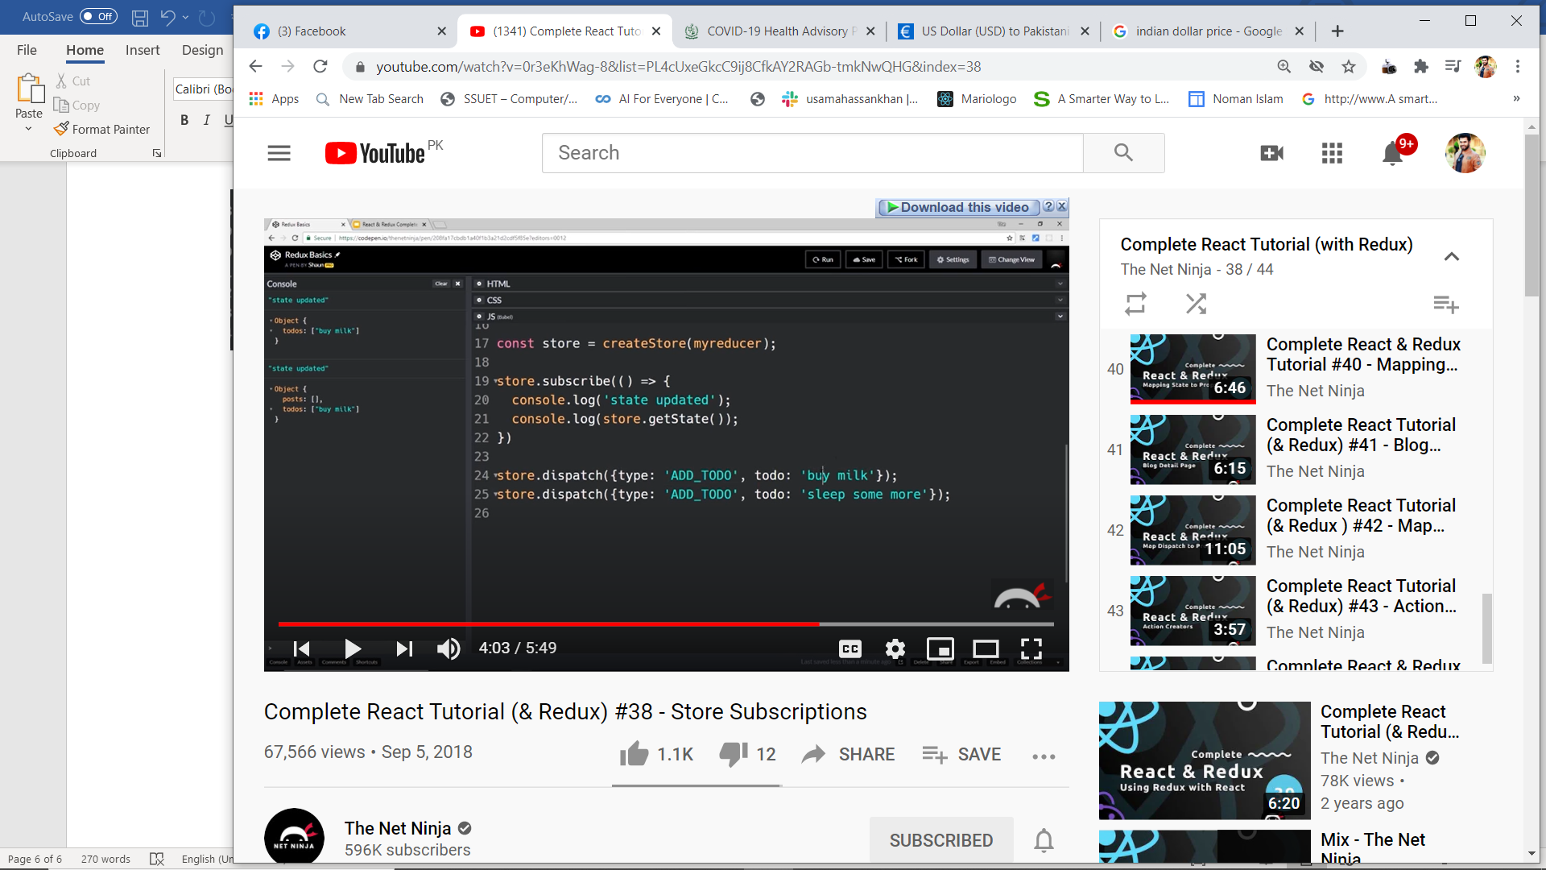

**Implementation**

Npm install redux react-redux

In index .js

Add *import* {createStore} *from* 'redux';

Const =createStore());

And wrap with proveder

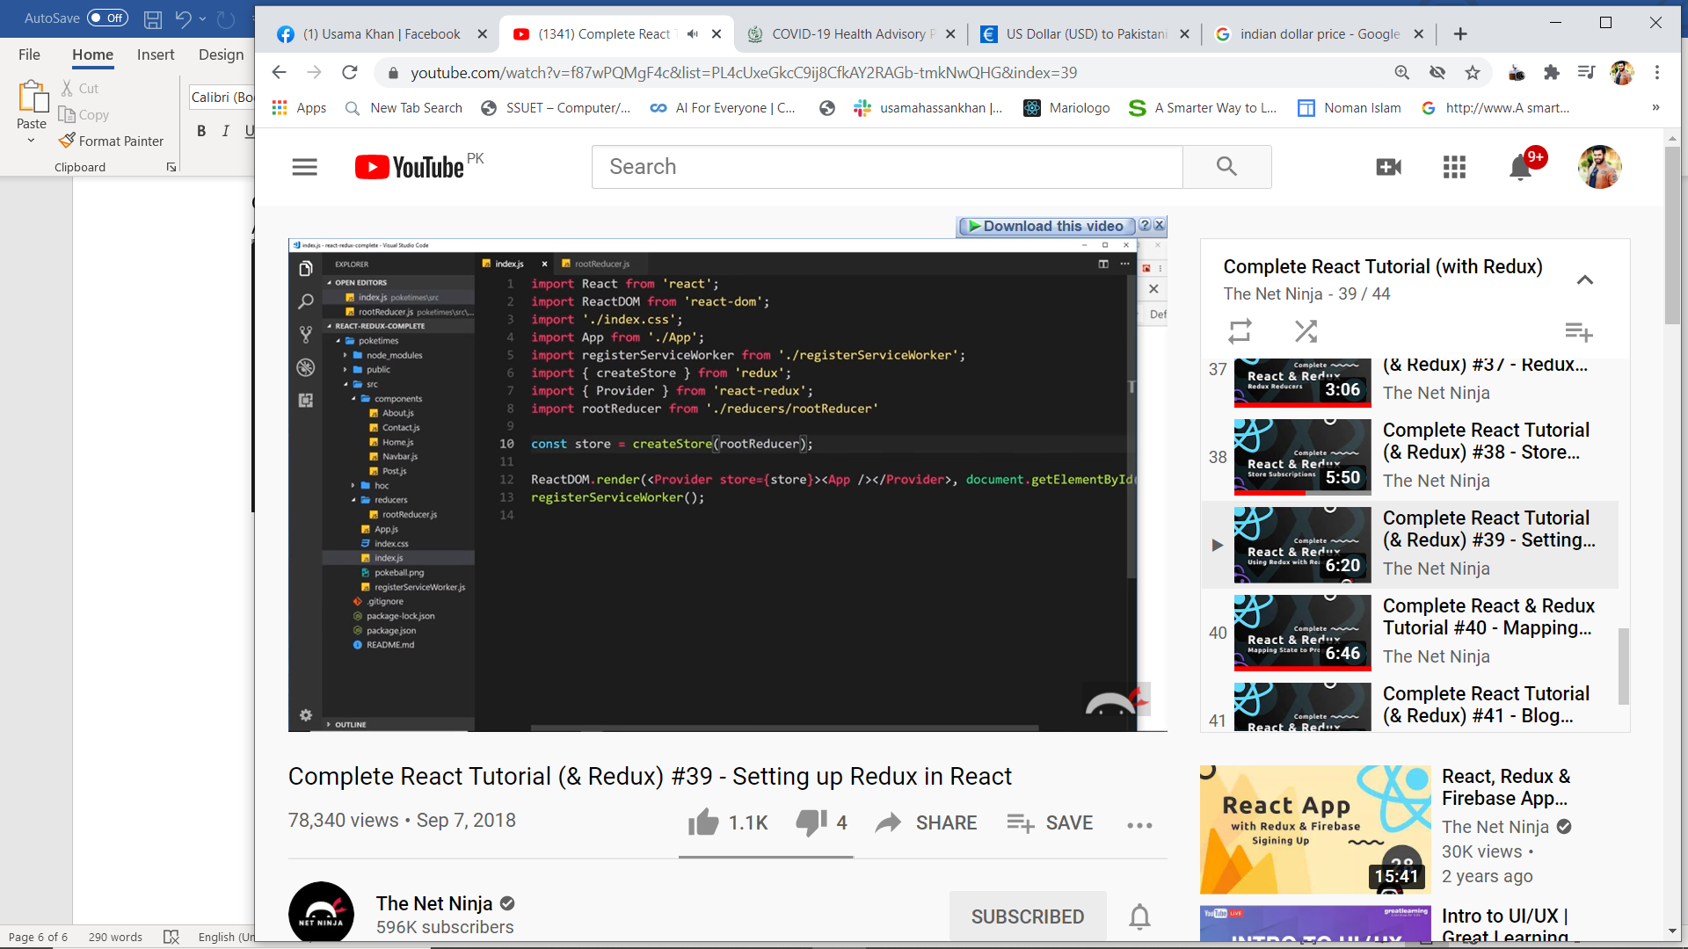

Now whener eu wana use reudx state

Import

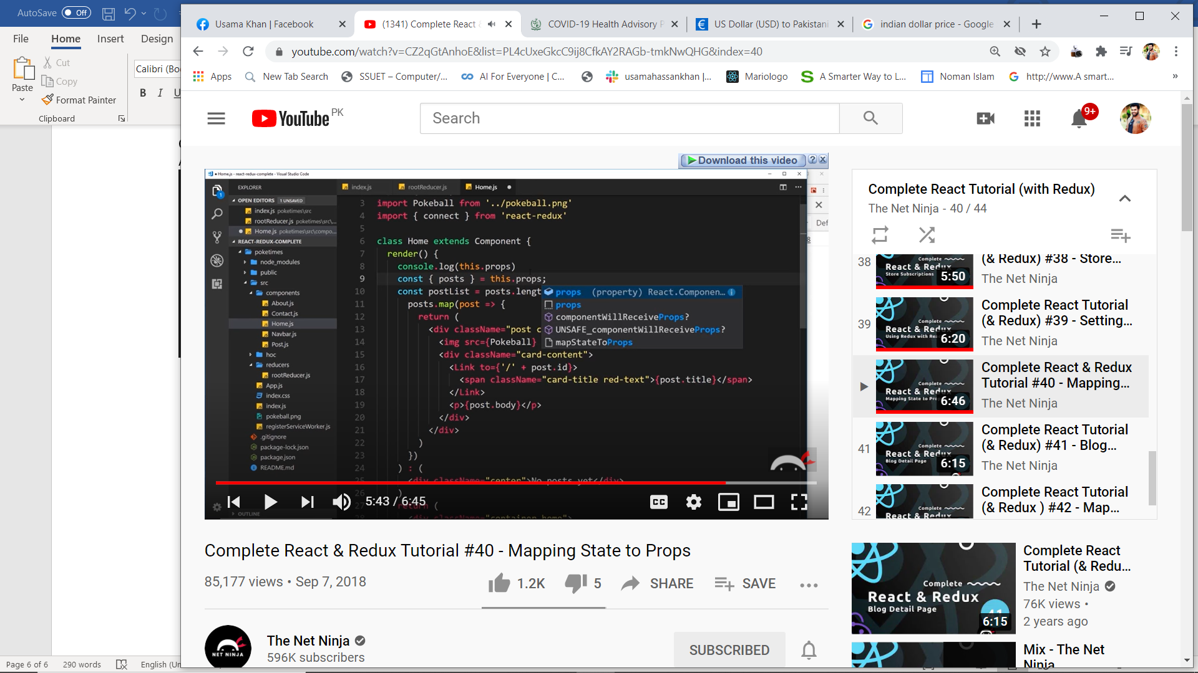

Then

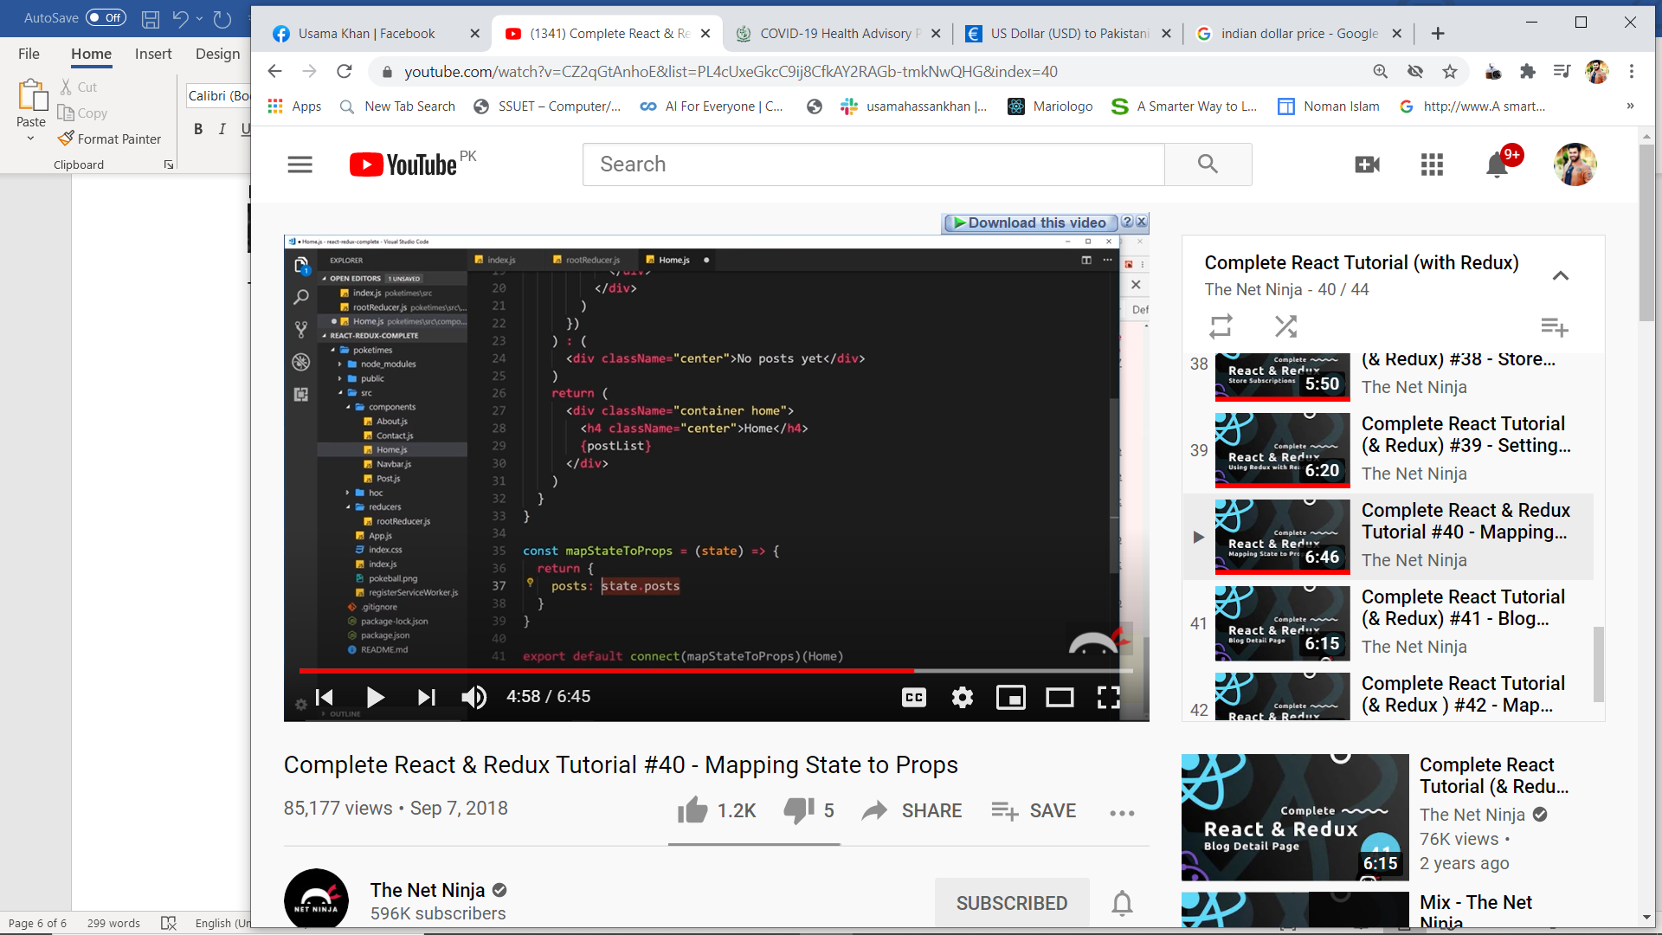

**Here now u can use this .props.posts every where**

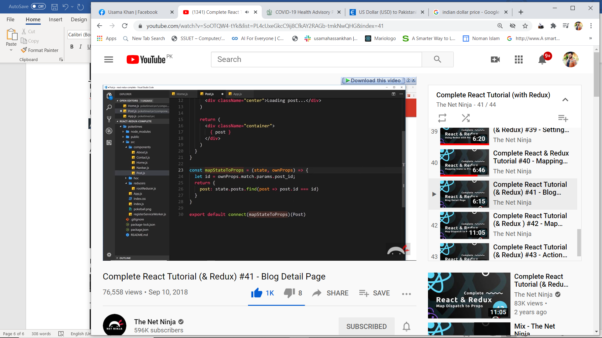

**Here own props is for getting route property**

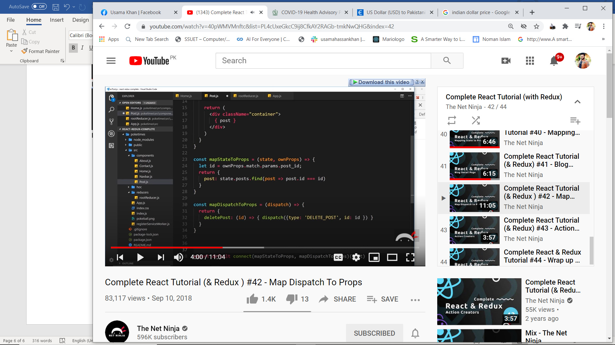

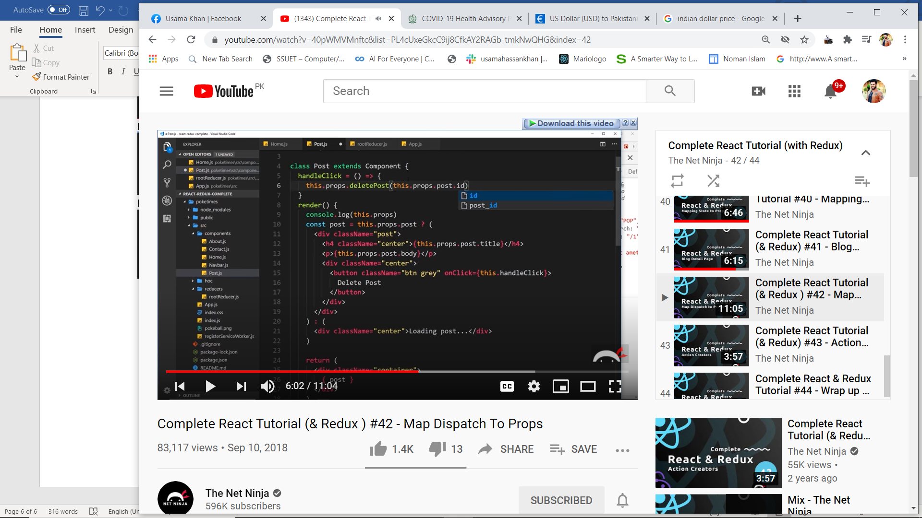

Onclick={handleClick}

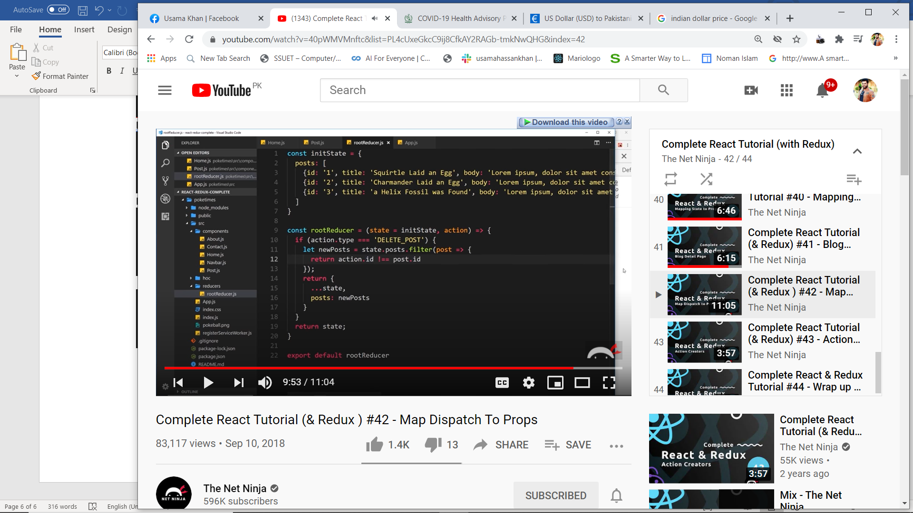

Create separate action creator

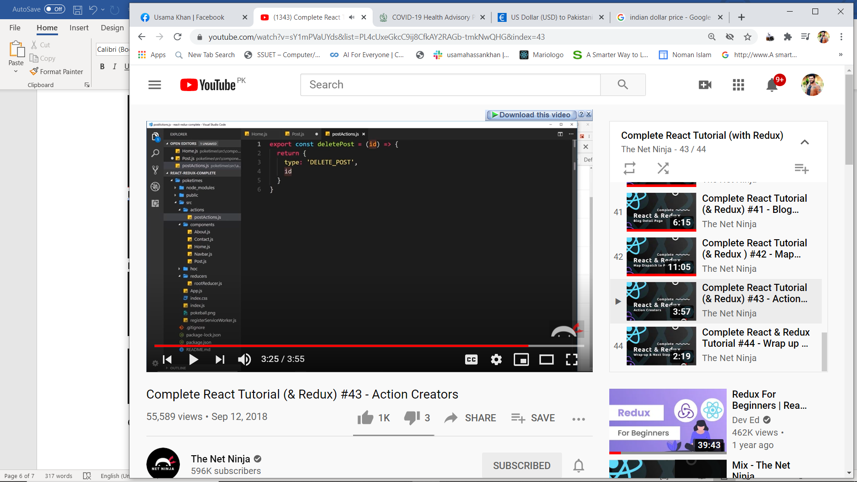

And replace dispatch from these

